Cameron’s Cheat Sheet
to the
QuantaCyte Flow Cytometer

Table of Contents
High-Level Summary of Quantum P Flow Cytometry 1
DNA Staining Protocols, Sample Prep 2
Flow Cytometer Machine Prep, Sample Loading 4
CyPAD: Overview 5
CyPAD Layout: Batch List 6
CyPAD Layout: Charts/Plots 7
CyPAD Layout: Analysis Results 9
CyPAD Layout: Cytometer Tools 10
CyPAD Layout: Control Panel 16
CyPAD: Reporting 17
Troubleshooting 19

High-Level Summary of Quantum P Flow Cytometry
Flow cytometry is used in our case to accurately estimate the genome size of a plant sample, and by extension, to identify the ploidy level of that particular member within a plant population. The process begins with finely chopping a small amount of material from properly-kept samples, as well as a reference tissue with a known genome size to use as standard. Samples may be used fresh by chilling them in a slightly moist bag, or freeze-dried immediately after collection to last several months.

Next, a reagent kit is used for nuclei extraction (to strip the tough plant cell walls) and fluorescent DNA staining. The exposed and stained DNA is held by the nuclei, which is then fixed and suspended in a buffer solution. Two different reagent kits are used for this machine’s 2-laser setup: CyStain UV Precise P for use with the 365nm UV laser (L1), and CyStain PI Absolute P for use with the 488nm blue laser (L2). Although there are more nuanced use cases, UV Precise P is faster, but PI Absolute P staining is more consistent and accurate.

A specified amount of sample is drawn in by the flow cytometer by a syringe, and is pumped into the flow cell. Sheath fluid is pumped from a large glass jug into a conical hydrodynamic focusing region, which surrounds and concentrates the steam of nuclei into a single file line down through the flow chamber at a uniform velocity.

The light stage contains the two lasers which (through a series of mirrors) shine through the narrow middle of the flow chamber, as well as two photosensor devices. One is placed perpendicular to the laser which measures fluorescence, with the other placed behind the laser to measure reflected light, or ‘backscatter’. The stained nuclei pass through the flow chamber, and momentarily pass through the laser. The fluorescence of a particular nuclei correlates to the amount of genetic material found within the cell (an estimate for the genome size of a normal cell in G1 phase), and the reflectance correlates to the size/granularity of the object which passed through the laser. This can be used to gate off junk particles that still reflect UV light.

The nuclei then passes through the back of the flow cell, and is pumped into the waste jug. When all of the sample is processed, the machine rinses the flow cell and the tubing, and is ready for the next sample.

The fluorescence and backscatter of each particle passed through the flow chamber is recorded to the Cypad software. The data may be organized in various ways, but for common, high-throughput assays, the fluorescence value is plotted along a histogram. In preparation for this, the optimal gain of the photosensors should be set to record the data properly. In a properly prepared sample, there will be three large peaks: the ‘noise’ peak of weakly fluorescent debris and tiny bubbles (centered on the origin), the standard/reference peak, and the sample peak. Based on the peak analysis of the data, the sample’s genome size will be estimated based on the known size of the standard and the ratio between the means of the standard and sample peaks. This may be done in the Cypad software, or calculated in an excel report sheet.

DNA Staining Protocols, Sample Prep
The sample prepping protocols are fairly straightforward. I have linked two Cystain protocols below.

Cystain UV Precise P is used in conjunction with the UV laser (L1, 365nm). The DAPI stain it uses is not as accurate as the PI stain, due to it only fitting into the minor groove of mostly A-T rich regions of DNA. It does not require an incubation period, and thus is useful for high-throughput processing. The stain itself fluoresces in the blue wavelength (460nm).

https://us.sysmex-flowcytometry.com/media/pdf/6d/77/36/05-5002-CyStain-UV-Precise-P-TDS.pdf

Cystain PI Absolute P is used in conjunction with the blue laser (L2, 488nm). It provides accurate measurement due to the Propidium Iodide (PI) stain binding between the base pairs of the DNA helix (intercalation), making it very consistent. It requires 30-60 minutes of an incubation period before a sample may be used, as the RNase degrades the RNA to ensure the PI binds only to DNA. The stain itself fluoresces in the red wavelength (617nm).
https://us.sysmex-flowcytometry.com/media/pdf/e3/dc/f2/05-5022-CyStain-PI-Absolute-P-TDS.pdf

Protocol Tips
- When collecting a sample, chill immediately. If analysis will follow in the following days, store in plastic bags with slightly moist paper towels. If analysis will follow further out, freeze completely, sublimate using freeze drying, and store in a cool place.
- When choosing a standard/reference, choose a consistent, readily-available species. Choose a standard that is somewhat close to the estimate of the 2N genome size of the sample, but not so close that their peaks are laid atop each other. I recommend a difference of the 1C genome between 1-4GB. I prefer the standard genome being smaller than the sample, otherwise, if I process a sample that is polyploid and it ends up on the other side of the standard peak, I would have to remember to switch the peak means in the columns of my report sheet.
- Although the buffer solution is completely harmless, one should be especially careful when performing the PI Absolute P assay to not allow RNase contact with the skin or inhalation of vapor, as the degradation of RNA could cause irritation and damage to skin cells. It is considered mildly toxic. One should also not spill the diluted vial on themselves for this same reason. If contact occurs, flush the area with clean water and soap for several minutes.
- Use samples as quickly as possible, and store in a cool dark place when not in use. Waiting too long after incubation (or final combination) can cause a precipitate to form on the bottom of the vial which can clog the machine and give bad data.
- Using a disposable razor blade, I prefer to use one corner per sample (2 sides*2 corners = 4). Clean the blade with ethanol after each use. Reusing the same blade can crush cells instead of slicing them open, which lowers the quality of the data.
- Be sure not to add too much nuclei extraction buffer onto the petri plate, or leaves will float around and be difficult to cut.
- The amount of plant sample and standard to chop can vary on the species and technique. Some assays say to use up to 5 cm2 of both sample and standard, while others suggest to cut half as much sample as standard. See Troubleshooting for finding the right balance in order to define high quality peaks.
- At times, there will be compounds in the plant material that are naturally fluorescent. Diploid Sagebrush has one such compound. If tests show the detector data is completely blown out, use a glycerol centrifuge column protocol (usually paired with UV Precise P) in order to extract the fluorescent compounds.

Flow Cytometer Machine Prep, Sample Loading
Ensure the Flow Cytometer has the sheath fluid bottle properly sealed and filled (up to and not above the base of the conical top of the bottle– if the head pressure is different due to the surface area of the water being different, it can cause problems.) and that the waste fluid bottle is empty as well (does not necessarily need to be sealed for pressure like the sheath fluid bottle but it smells). When the sheath fluid begins to run empty, refill the bottle (up to the base of the neck) with dedicated sheath fluid or DI water, and dispose of the waste bottle in proper chemical waste. DI water may be used to refill the sheath fluid bottle, but flow cytometers work best with a slightly salinated solution. Some labs mix 0.5x Phosphate-buffered saline (PBS) with DI water to this end. I would avoid switching the kind of fluid within a session.

When all samples are prepared and incubated if necessary (see DNA Staining Protocols, Sample Prep), ensure the flow cytometer is on, connected to the CyPAD software, and ready to receive samples. Only run the machine and the laser within when you are actively processing samples to extend its life. From the CyPAD software, there are many more variables to check in order to ensure proper analysis (see CyPAD: Overview). To begin processing a sample, load a vial fully into the dock (should have a firm snap at the very end), and tilt the bottom into the machine. The machine will pull a preset amount of fluid to be analyzed (the aspiration volume, see CyPAD Layout: Cytometer Tools in the Cytometer Configuration: Acquisition Tab), and then the analysis will begin. Always ensure that whenever the machine is drawing liquid from a vial, there is ample liquid within the vial. If the machine attempts to draw fluid from an empty vial, air bubbles can become incorporated within the tubing and cause pressure problems when trying to draw from future vials (see Troubleshooting).

As soon as the machine begins the analysis of the vial, I like to remove the vial and preload the next sample (load but don’t tilt in) so that all one has to do is tilt in the vial when the previous sample and the rinse cycle finishes. I usually prepare 2ml of a sample, and set my aspiration volume to be 800-100µL (maximum of the machine). This way, I can have a full backup sample run in case something goes wrong with the first. It is also useful to make an extra sample to run in the beginning to figure out what gain works best without draining the real samples (see CyPAD Layout: Cytometer Tools). Make sure however to press the vial fully into the loading dock, or else backflow can ruin the sample (see Troubleshooting).

CyPAD: Overview
Through the CyPAD software, the drawn sample vial’s fluorescence datapoints will be loaded in and recorded. After all fluid is processed (or Stop is pressed in the Control Panel), the sample row will be complete and recorded to the Batch List. Every run will create a sample row, so ensure to clean up test runs using Remove above the batch list. Peak analysis may be done on the entire batch in order to record peak data (see CyPAD: Cytometer Tools, Ploidy Analysis). Once each sample has 2 high confidence peaks associated with it, the data may be exported using the Report function (see CyPAD Layout: Reporting). At the end of a session, always use the cleaning protocols (see CyPAD Layout: Control Panel).

1. Batch List: Every processed sample is stored in a batch, which may be saved and opened.
2. Charts/Plots: Incoming data is directed to the plots, which can be arranged in tiles, both axes may be changed, and the reading detector chosen.
3. Analysis Results: Contains detected peak info (scroll down within Charts/Plots window).
4. Cytometer Tools: Contains detector information– which is the lead (master), the gain, and lower limit. Also contains gating and peak analysis options.
5. Control Panel: Contains sheath fluid speed, a ‘clear’ button to wipe data from plot, start/stop buttons, and options for cleaning cycles.
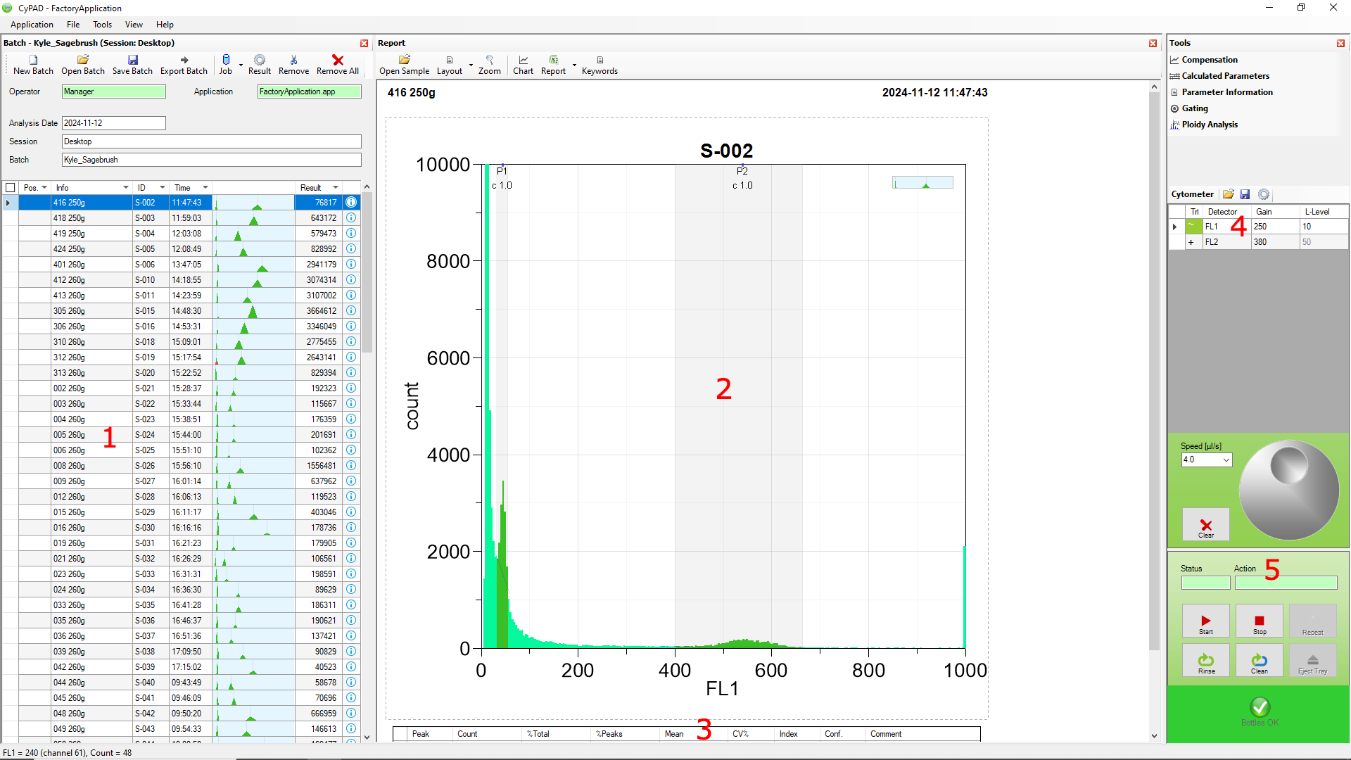

CyPAD Layout: Batch List
Menu Bar
Application: allows one to open or save an application, holding the batch data and all setting presets. The Edit button is used to load the files containing the cytometer, SPU (single particle unit), Layout, and Report settings. See the Reporting section.
File: allows one to save, open, or print the selected sample and its data.
Tools: requires SPU functionality, ignore
View: Changes what windows are displayed.
Help: Little functionality, only has Cypad version number information

One may create a New Batch, or open an existing one with Load Batch, or use Save Batch to save the current one. Saving a batch contains all information within the session (instrumentation settings + sample results). I have no idea what exporting the batch does, nor is the button mentioned in the actual manual.

The Job button is used for Jobs, used for repetitious well plates where one can code in what each well is. I have never used them.

The Result button allows one to change what is displayed in the Result column. The default is total datapoint count.

The Remove and Remove All buttons can be used to trim jobs from the job list. At the end of a batch, I like to use the Remove button to remove jobs to make the report look more clean (if that’s how one wishes to record the data).

Column Descriptions
Pos: Contains information for position in ‘job’. Jobs are only really useful for large well processing.
Info: A text box which the user can record any desired information in. I use it to note the sample number inscribed on a sample’s envelope and sometimes the gain, since gain cannot be loaded into the report. However, if one just writes the sample id into the Info box and keeps the same gain, it can easily be translated into the report and the gain duplicated for all rows after the report is generated.
ID: A CyPAD-given identifier for the particular run.
Time: Time of day the run began.
<Blank>: A small histogram of the detected peaks. Note that a red mark at the bottom of a peak represents a low-confidence peak (high CV%)
Result: Total number of readings in histogram. Note that if one uses this as a sort of standard in which to know when a run has enough information, one should carefully place the L-Level in Cytometer Tools so that the ‘mess’ peak on the left is not captured.

CyPAD Layout: Charts/Plots

The Open Sample button allows one to open a particular sample after being saved with file->save. Identical to file->save. I do not use this since saving the batch contains all samples processed anyways.

The Layout button allows one to display more than one plot at a time.

The Zoom button zooms into one of the plots (if there are multiple).

The Chart button brings up Chart Properties, the same window brought up by right clicking the chart->Format Chart (below).

The Report button can export an excel sheet based on information from the samples and peaks recorded. It’s sidebar loads what template one uses. More information can be found in the Reporting section of the guide.

The Keywords button contains the syntax format used by Report templates.
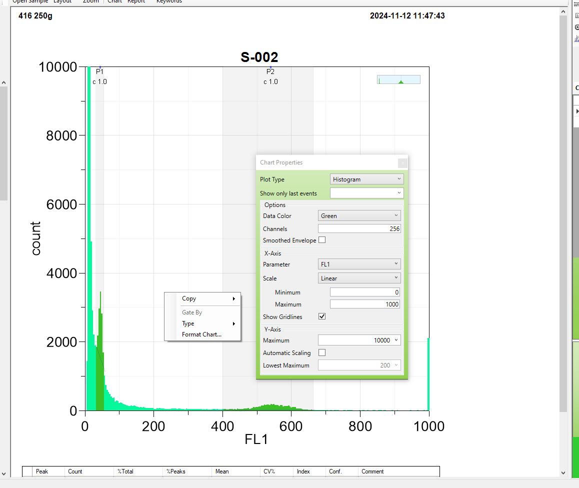

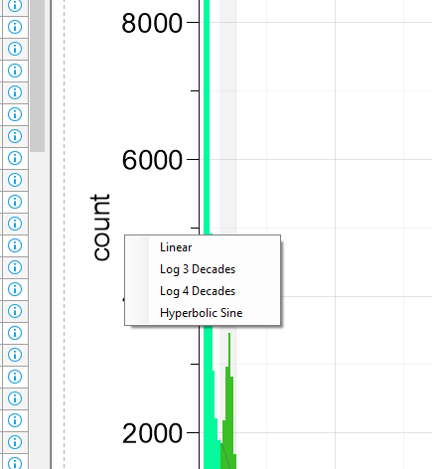
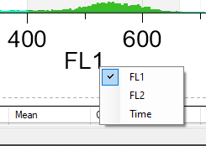
The chart registers incoming data, but one must ensure to use the right detector for which laser one is using (FL1 vs FL2). To change the detector to display, simply click the x axis title and choose the proper detector. Incoming data can be displayed linearly or logarithmically by clicking on the Y Axis.The chart style itself may be determined by right clicking the chart->Type->Histogram, Dot Plot, or Density Plot.

A Dot Plot and Density Plot in this machine compare the readings from the FL1 and FL2 detectors, since dyes often spill into both channels. From here one can identify outlier regions (especially when comparing against the histogram peaks) in order to identify the desired data points in poor quality samples. The Gating function within Cytometer tools is useful for only using data that falls within a certain region. For high-throughput work for identifying plant ploidy numbers, however, just using the Histogram is usually sufficient.

CyPAD Layout: Analysis Results
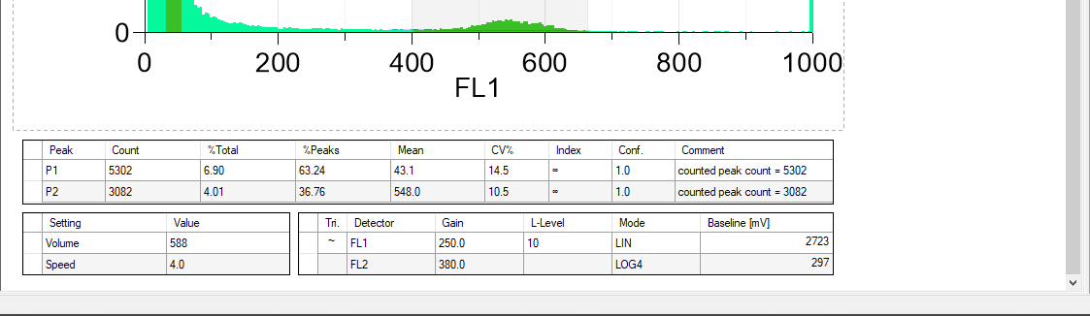
Contains peak data and setting information from when the sample was processed. The top table contains peak information derived from the Peak Analysis function (see Cytometer Tools). There should never be more or less than 2 peaks in a sample before it is ready to output. See troubleshooting

CyPAD Layout: Cytometer Tools
Tool Buttons
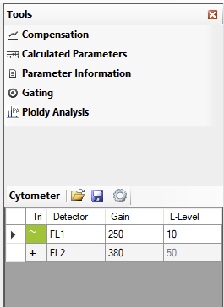
Compensation: balance photo sensor levels if both sensors were being used (unused).

Calculated Parameters: calculate values based on raw readings based on a formula (unused).

Parameter Information: calibrate photo sensors and time measurements (unused).

Gating: used to draw regions to gate off data in order to record count of points within the gate. More useful for discarding junk readings while viewing the data in a Dot Plot or Density Plot (right click chart->Type).

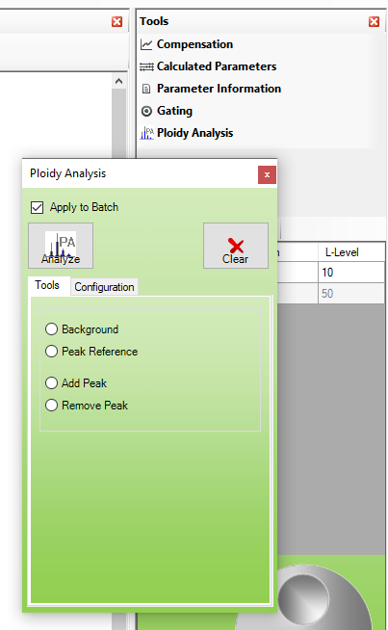
Ploidy Analysis: (bottom right) used to automatically identify peaks within the data. I usually check ‘apply to batch’ and press Analyze at the end of the session, then manually check every sample. If a peak is not represented, ensure the quality of the specimens is acceptable and the peak is visually prominent. If not, redo the sample. If so, select Add Peak and click the middle of the peak. If a peak was automatically counted that is not a real peak, use Remove Peak. The parameters of what it considered a high and low quality peak is determined in the Configuration tab. A low quality peak will appear with a red tab in the mini display column of the sample list.

Cytometer Buttons
Open and Save: Does nothing apparent
Gear: Opens Cytometer Configuration

Cytometer Table

Tri: double clicking sets a laser as Master, ie the laser one wishes to record data from properly. The master laser will have a green tilde within the box, and all slaves a white-backed plus sign.

Detector: displays the name of the detector. FL1 is designed to detect fluorescent excitations from the L1 laser, with FL2 detecting L2.

Gain: used to set the gain, or sensitivity, that the sensors detect at. Lower Gain levels are less sensitive, and pull data towards the origin. Higher Gain levels are more sensitive, expanding data out across the axis. For working with samples of a few gigabases, a gain roughly somewhere around 200-500 would be a good place to start to find the ideal gain. An ideal gain would be high enough to place the near peak separate from the mess peak that accumulates on the origin, while low enough to ensure that the further peak data does not accumulate off the chart, as this data is lost (it is not a restriction of the x-axis that data pools at the end, it is a hardware restriction in the detector). If there is a tall column accumulating at the 1000 mark on the x axis, lower the gain to see if one is missing any peaks. I find having the near peak sitting somewhere around 25-100 on the x-axis leaves ample room for the far peak (especially if the far peak is the sample and I am working with 6x polyploids). I highly recommend making an extra sample in order to find the proper gain for the session, as changing the gain can slightly warp relative placements of the peaks in relation to each other when one is comparing individual samples’ peak height ratios.

L-Level: sets a floor to the data recorded. I prefer setting a very low L-Level to ensure I am not missing the near peak, although having too low of a L-Level requires one to remove the peak when one does peak analysis.

Cytometer Configuration: Service Button
Used to observe machine status and for manual pump priming. See Troubleshooting.

Cytometer Configuration: Acquisition Tab
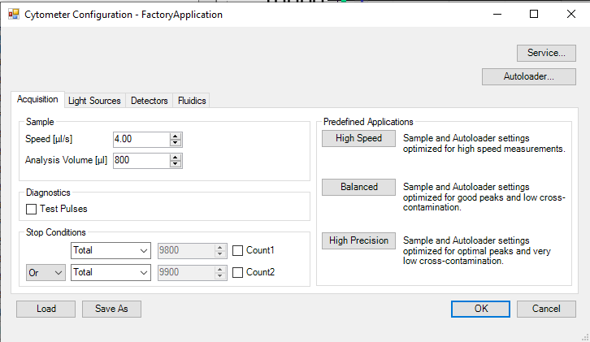
Here one may set the sheath fluid speed and analysis volume of the sample. The maximum draw volume is 1000 microliters, and I recommend something close to this in order to gather enough data to create high quality peaks. One may also use the Predefined Applications to use preset draw speed and cleaning thoroughness of the machine.

Cytometer Configuration: Light Sources Tab
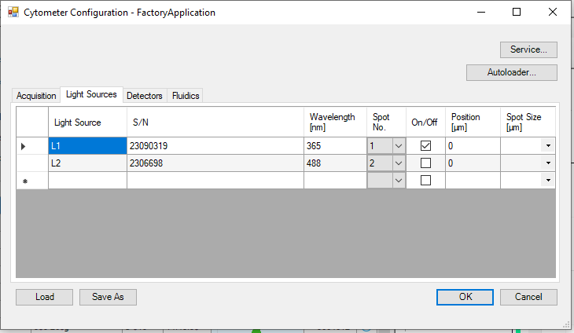
Here one may turn on or off lasers. L1 is used in conjunction with the Cystain UV Precise P reagent kit, and L2 is used in conjunction with the Cystain PI Absolute P reagent kit. There are no situations where both lasers should be on. This is the only place where the lasers may be turned on or off, so make sure to check here when setting up for a new session.
Cytometer Configuration: Detectors Tab
Here one may identify one laser as the master and the other as the slave. Data recording is tied to the master laser’s pulse to ensure its fluorescence data is collected. Setting the Trigger to Master is the same as double clicking a laser in the Cytometer Table. One may also set the L-Level (lower level) or data recording to set a floor on incoming data in order to remove the mess peak (also may be accessed in Cytometer Table).
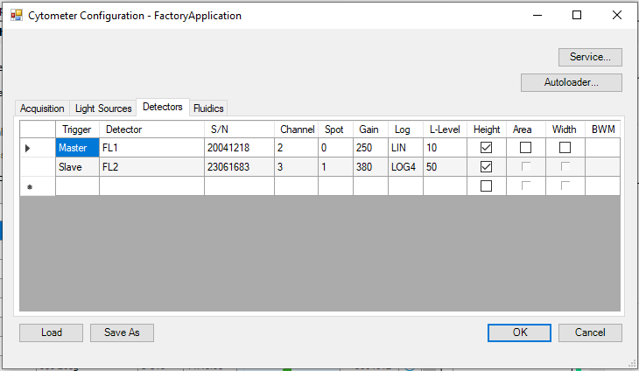

Cytometer Configuration: Fluidics Tab
I would recommend leaving the ‘Stop Measurement when Tube Removed’ box unchecked to allow more efficient trading of vials during a session. One can remove a vial as soon as the machine is done drawing the fluid and has begun to analyze the fluid. I sometimes also set ‘Cleaning Cycles’ to more than 1 if I am seeing lots of messy data at the end of a day.
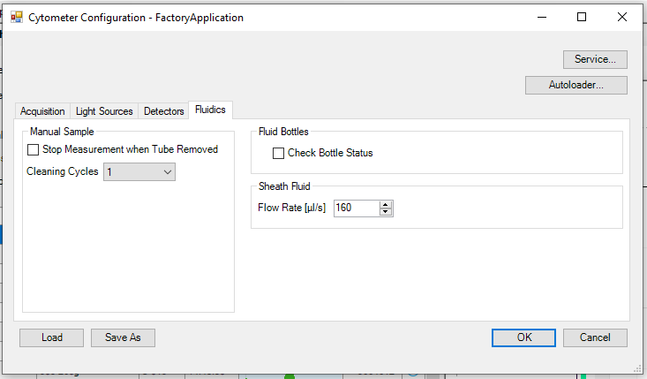
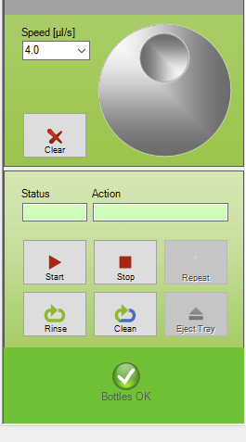

CyPAD Layout: Control Panel
Speed: used to set the speed of the flow cell. I usually keep it on slow (2 microliters/s) but if I have clean samples I put it on average speed (4 microliters/s).

Clear: used to clear all data from the selected sample. Always clear the data when the gain is changed. Data cleared in this way cannot be retrieved.

Grey Dial: rotate with mouse after clicking a text box with a numerical value in order to incrementally increase or decrease it. I never use it.

Start: begins analysis of the sample. Usually, this process will begin when a vial has been fully placed within the drawing holster and pushed to be oriented vertically against the machine.

Stop: stops analysis of the sample. This process will also occur when the selected amount of liquid is processed from the sample. If pressed while the machine is processing a sample, all remaining sample liquid will be discarded. A rinse cycle will automatically follow.

Rinse: performs a rinse cycle in order to clean the sample vial of material, drawing from the sheath fluid bottle.

Clean: opens up the Advanced Cleaning and Maintenance Menu. Descriptions are self-explanatory. Use them often. It is crucial to perform ‘Clean System’ after a session in order to prevent build-up within tubes. Also ensure to use vials with more than 1000 µL of green/blue soap so that the system does not suck up air after drawing the vial empty. See troubleshooting.
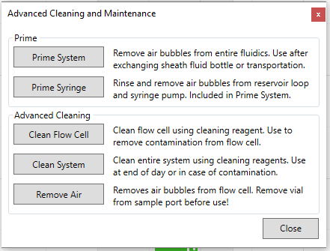

CyPAD: Reporting
Reporting allows one to export information (including peak information) from every sample in the batch list. A Report Template is used with keywords (listed in the larger manual) in order to fill columns with specific info from each sample (with each sample representing one row of data). I have created the custom template ‘Cameron’s Gate Report (QA).xls’ in order to draw information relevant for my work but one should alter it to suit their purposes.

In order to select the report template to be used as default, select it through Application (top left) -> Edit -> Report Template (default is .xls, Microsoft excel 97-2003 format, not sure if others work). This works easiest if the .xls is placed with the others in /Documents/CyPAD/Reports/.
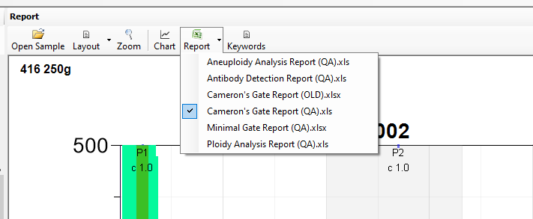
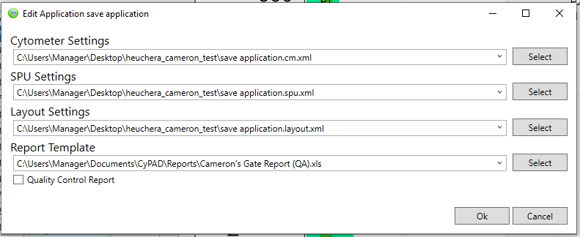
Make sure the drop down arrow next to the Report button is selected to the .xls report format that is intended to be used.

Then simply click the Report button when the batch is finished and peaks are identified.
‘Cameron’s Gate Report (QA).xls’ will generate the following columns. NOTE: use only if the standard is the smaller genome relative to the sample one is processing. If the sample is smaller than the standard, use the template ‘Cameron’s Gate Report sample<standard(QA).xls’. All that changes is that std_mean uses the second peak and sample_mean the first peak instead. I encourage you to create a new template that fits the particular demands of the work.

sample: Contains the unique sample identifier created by the particular sample. The first run will have the sample identifier ‘S-001’. Cutting samples from the list may leave gaps, so it should be used merely as an unique identifier number, not as a sample number.

info: Contains the string of text the user has inputted into the info box. I use it to note the sample number inscribed on a sample’s envelope and sometimes the gain, since gain cannot be loaded into the report. However, if one just writes the sample id into the Info box and keeps the same gain, it can easily be translated into the report and the gain duplicated for all rows after the report is generated.

gain: An empty column designed to hold the gain of the sample. Simply input the gain used for the session into C2 and double click the bottom right to duplicate the value to the full sheet in excel if the same gain is maintained for the entire session.

std: An empty column designed to hold the standard used in the session. I usually use the letter code associated with the species, or the first two letters of the name, such as AcNe for Acer negundo. Simply duplicate the std value to all rows after the report is generated as above.

std_1C: An empty column designed to hold the 1C value of the standard used in the session. Simply duplicate the std value to all rows after the report is generated as above.

std_mean: Contains the mean of the first peak detected for the sample, or the second peak if the alternative template is used.

sample_mean: Contains the mean of the second peak detected for the sample, or the first peak if the alternative template is used.

C_value: Contains the formula ‘(sample mean / standard mean) * standard 1C’ to calculate the C_value of the unknown sample.

C2_value: Contains a value double that of C_value, representing the size of the entire genome.

rel_fluoresc: Contains the ratio between the sample mean and the standard mean. Used in some analysis.

notes: An empty column designed to hold any particular notes or remarks one makes concerning the sample. Sometimes I write here if the sample was of particularly poor quality or something of the like.

Troubleshooting

Data is being displayed but peaks are difficult to spot.

- There is a high count of data at the very end of the histogram’s x axis (at the 1000 mark).
  - This means there is a significant amount of data that extends beyond the range of the detector. To fix this, decrease the gain, making the detector less sensitive. Note that setting the x axis to logarithmic instead of linear cannot “create” data that was plotted past 1000, as it is a hardware limitation from the gain.
- Peaks are visually apparent, but not prominent enough to be detected by the peak analysis (a “bump” along the side of the mess peak).
  - Rerun sample with a higher gain to spread data out. If gain is not the problem…
  - If the smaller genome belongs to the standard, it might be too small and getting absorbed into the mess peak. Consider a larger sized standard.
  - If one peak is significantly weaker than the other, redo the DNA staining protocol and add slightly more material of the corresponding plant. It is usually common for the smaller genome peak to be much taller than the larger genome peak, due to readings becoming more spread out the brighter they are.
  - Just for ploidy diagnosis, it is admissible at times to “eyeball” the mean of an apparent peak within the data if it is impossible to gather more sample. Due to constructive interference, a “bump” may appear on the side of a larger waveform, which is formed from the construction of the two distributions. Because of this, manually mark the peak as slightly away from the mess peak in order to get the most accurate approximation.
- The leftward mess peak is thick and blown out, covering the rest of the data.
  - Rerun sample with a lower gain to pull data back. If gain is not the problem…
  - Ensure to collect material from a plant from the freshest-looking piece of it. A cutting that has browned/blackened even slightly will not yield quality data.
  - Try using less material. Too much plant material can cause too high of a density of cells being shot through the flow cell, and can cause it to become blown out.
  - If one lets vials sit out for too long (not in a dark, cool environment), a precipitate can build up at the bottom of the vial. These samples are always of poor quality.
  - Worst case scenario, there could be buildup in the tubing within the machine that could cause poor data quality like this. The blue ‘soap’ is an enzyme cleaner that helps break down proteins. Ensure to use the full ‘Clean System’ cleaning process at the end of every session.
- The leftward mess peak is thin, but all that can be seen.
  - Right click the chart->Format Chart->uncheck Automatic Scaling, set Y-Axis Maximum to something reasonable.
  - If you want to keep Automatic Scaling, Adjust L-Level to be higher by a few 10s in order to not have the scaling blown out by the mess peak
  - Otherwise, add more material of the corresponding peak that does not show.

Data is not being displayed, liquid still drawn from vial.

Check if:
- The laser is the correct one for the protocol (CyStain UV Precise P for use with the 365nm UV laser (L1), and CyStain PI Absolute P for use with the 488nm blue laser (L2).
- The correct laser is on (cytometer configuration gear icon -> light sources).
- The correct detector is the master (cytometer configuration gear icon -> Detectors -> Trigger column, OR can be changed by double clicking square in Tri column of detector table on the right of the window: a green tilde means it is the master).
- The correct detector is being shown on the main plot (double click x axis title beneath axis, select detector FL1 or FL2).

Otherwise, if there is still some scattered data, but nothing substantial:

Set the fluorescent standard beads to see if that can be read. Even DI water should always carry a few bubbles which will be read into CyPAD as noise. Make sure to lower the L-Level in the Cytometer Tools to see the mess peak. If absolutely nothing is being shown, CyPAD is not displaying the right data for some reason (see above checks). If fluorescent standard beads can be read, but not the sample, make a vial with a fresh plant sample of a known standard. If this data appears good, it could mean that the sample used in the vial is of poor quality, and a new sample is required. If the sample appears poor, this could point to the DNA staining protocol not being effective, either due to user error, improper storing conditions, or expiration.

Liquid is leaking during analysis.

Check if:
- The vial is pressed firmly into the loading dock (should have a firm snapping sound made at the end). A pneumatic seal must be made in order to draw out the liquid. If not, backflow from the pressures within the flow cell will ruin the sample and overflow the vial.
- The vial you are using is a newer one, and its top lip is not cut up or worn. A worn edge will not make a good pneumatic seal.

Otherwise, if the leak is coming from the vial itself, or from tubing at the base of the loader or even deeper within the machine. Remove the front plate of the machine to investigate this further, and perform a run after turning OFF the laser. It is not uncommon for the microtubing that is stretched around the metal nubs of ports to grow weak and hard over time. Simply cut new tubing and replace it if it fails to make a seal. It may also be necessary to use small zip ties to fully tighten the tubing onto the metal ports.
Liquid is not being drawn from the vial

Check if:
- The vial has been inserted high and snug into the loader with a firm snap. A loose seal can prevent the start of the process, or overflow the sample due to backpressure.
- There are any errors displaying pressure problems (could point to a potential fix).
- If there is liquid pooling under the front of the machine. If so, tubing needs replacement.
- If while the machine is running a burning smell arises, like a vacuum cleaner stuck on something. If so, a pump is attempting to pull or push while meeting a great resistance. This is a sure sign of a clog, of either bubbles or material buildup.

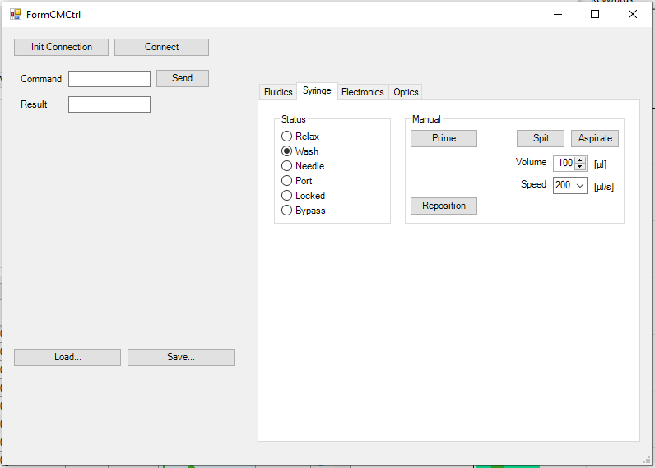
Run cleaning protocols, such as Remove Air, and hard reset the machine. If this does not fix the problem, attempt to “burp” the machine. Occasionally the machine will have a large bubble of air that is difficult to remove, and the machine refuses to attempt to pump out in an automated process. To “burp” the machine, go to Cytometer Configuration (gear on right panel) -> service (upper right) -> syringe.
Prime, then attempt to Aspirate or Spit several hundred microliters of liquid. Passing or drawing enough liquid through the machine, and running a Prime System cleaning maintenance should knock the pressure block out of the machine. If I suspect a clog, I sometimes aspirate the blue cleaning liquid, which carries an enzyme to eat away at the block.

This is sometimes caused when the machine aspirates when there is no liquid to aspirate, allowing a significant amount of air into the pneumatics. Avoid this by ensuring there is enough liquid in the vial during a sample run so it does not pull air.

